Example error: Images in PDF

No text alternative
There is no alt text for this image.

 | A11y automated checker | Acrobat accessibility checker
Result | Detected | Detected

AI-generated text alternative
MS Word guessed the text alternative as “A black background with white text. AI-generated content may be incorrect.”

 | A11y automated checker | Acrobat accessibility checker
Result | Not Detected | Not Detected

Should be decorative
This decorative non-text content should be marked decorative, but it has a text alternative instead.

 | A11y automated checker | Acrobat accessibility checker
Result | Not Detected | Not Detected

Poorly constructed text alternative: vague
The text alternative here just reads “quiz averages.”
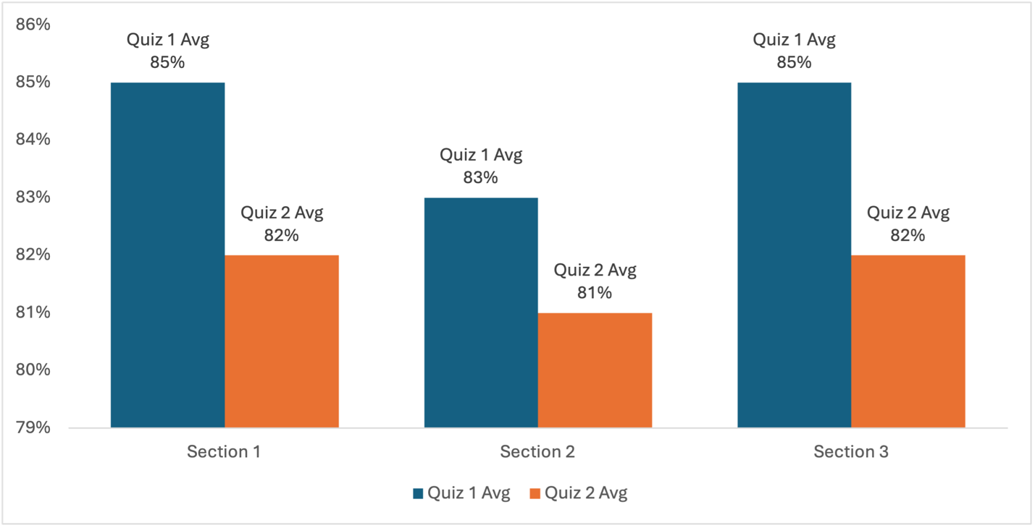
 | A11y automated checker | Acrobat accessibility checker
Result | Not Detected | Not Detected

Dense alt text
The text alternative here reads: “Grouped bar graph comparing Quiz 1 and Quiz 2 averages across three sections. Section 1: 85% and 82%. Section 2: 83% and 81%. Section 3: 85% and 82%.” This text alternative is 156 characters, which Ally incorrectly flags when uploading an image in the Rich Content Editor, but not here in a Word doc.

 | A11y automated checker | Acrobat accessibility checker
Result | No error to detect | No error to detect

Poorly constructed text alternative: inaccurate
The text alternative here is just the file name “RSUNJ_H_RED_BLACK_RGB.png.”

 | A11y automated checker | Acrobat accessibility checker
Result | Detected | Not Detected

Poorly constructed text alternative: gibberish
The text alternative here is just the file name “askdfjasldfkjasdf.”

 | A11y automated checker | Acrobat accessibility checker
Result | Not Detected | Not Detected

Poorly constructed text alternative: placeholder
The text alternative here is just the file name “image.”

 | A11y automated checker | Acrobat accessibility checker
Result | Not Detected | Not Detected

